24.57: a)
6.6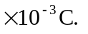The voltage over each is 660 V since they are in parallel. So:

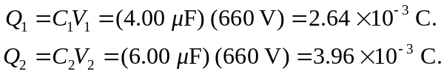

b)
so the voltage is V = Q/C = 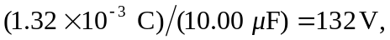and the new charges:

